RAYS Home/Away Swimming Facilities

Workout Club and Wellness Center (WCWC) - 16 Pelham Rd., Salem, NH 03079
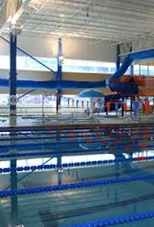
SITE: The WCWC pool is an 8-lane, 25-yard pool with six-foot-wide lanes and non-turbulent lane lines. A Fully-automatic Colorado Time Systems electronic timing with touchpads at the finish end of the pool with single-line electronic display is in use. There are no touchpads at the turn end of the pool. There is a small pool at the facility available for warm-up and warm-down. The finish end of the pool is 9 feet deep; the turn end of the pool is 4 feet deep. Spectator seating on deck and is very tight so we are encouraging teams to limit family members. The pool is located at the WCWC 16 Pelham Rd., Salem, NH 03079. Directions may be found later in this document. The competition course has not been certified in accordance with 104.2.2C(4).

COURSE: Short course yards (25 yards)
PARKING: There is ample parking available in the parking lot adjacent to the WCWC.
DIRECTIONS: The WCWC is located at 16 Pelham Rd., Salem, NH 03079. I-93 at exit 2.

Boston University - Fitness and Recreation Center, Boston, University, Boston MA
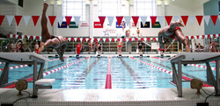
SITE Info: Boston University’s Fitness and Recreation Center includes a 10-lane by 16-lane competition pool with the ability to change from meters to yards using a movable bulkhead. The depth slopes from 7 feet to 13.5 feet. The course will be set in short course (25) yards, thus allowing 10 lanes with non-turbulent lane lines for competition and an additional five to six lanes for continuous warm up in the diving end of the pool. The facility is equipped with a Daktronics Timing System, touch pads, and a ten lane electronic scoreboard. Spectator seating is available for approximately 400 spectators

COURSE: Short course yards (25 yards) and Long Course Meters (50 meters).
PARKING: There is ample parking available in the Agganis Arena garage that is adjacent to the Fitness and Recreation center. As Boston University is an urban campus with many competing events, parking is limited. Metered on-street parking is discouraged as there are few of these spaces and they are frequently monitored and ticketed. Click here for Aquatic Center Parking Map that gives directions and illustrates how to access the Agganis Arena garage. The rate for each day is $1.00 per hour with a maximum of $8.00 for the day; however, if there are conflicting events on Friday, Saturday, or Sunday evenings at the Agganis Arena, all cars must leave the garage by 5:00 PM or they will be required to pay the $25.00 event parking rate. At this time, no events are planned for that weekend, but Boston University reserves the right to modify its parking terms and will make every effort to provide sufficient notification.
DIRECTIONS:
From the North Take I-93 or Route 1 South to Boston. Exit onto Storrow Drive. Continue on Storrow Drive to the Kenmore Square Exit. At the first set of lights, turn right onto Beacon Street. Bear right at the far end of Kenmore Square onto Commonwealth Avenue. Continue on Commonwealth Avenue to the Fitness & Recreation Center (approximately 1 mile).
From the South Take I-93 Route 3 (Southeast Expressway) North to Boston. Exit onto Storrow Drive. Continue on Storrow Drive to the Kenmore Square Exit. At the first set of lights, turn right onto Beacon Street. Bear right at the far end of Kenmore Square onto Commonwealth Avenue. Continue on Commonwealth Avenue to the Fitness & Recreation Center (approximately 1 mile).
From the West Take the Massachusetts Turnpike (I-90) East. Take Exit 18 on the left (Brighton/Cambridge). Follow signs to Cambridge. At the second set of lights, turn right. Continue on Storrow Drive to the Kenmore Square Exit. At the first set of lights, turn right onto Beacon Street. Bear right at the far end of Kenmore Square onto Commonwealth Avenue. Continue on Commonwealth Avenue to the Fitness & Recreation Center (approximately 1 mile).

Bowdoin College - Greason Pool Farley Field House Bowdoin College Brunswick, ME 04011
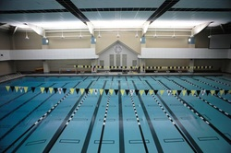
SITE Info: Named for former Bowdoin President Roy Greason, the Greason Pool features 16, deep water, 25 yard long lanes and seating for several hundred spectators. The pool also has one and three meter diving stands and is equipped to meet all the needs of Bowdoin’s swimmers, divers, and water polo players

COURSE: Short course yards (25 yards).
PARKING: There is ample free parking available in the Farley Field House parking lot.
DIRECTIONS:
From the South
- Take Interstate 95 north to I-295 exit (South Portland/Rt. 295).
- Follow Route 295 through Portland to exit 28 (Route 1).
- Follow Route 1 for about two miles. As Route 1 bears off to the left at a set of lights, stay straight on Pleasant Street.
- Pleasant will end at an intersection with Maine Street in Downtown Brunswick. Take a right on Maine and travel approx. a quarter of a mile.
- After a white church, take a left on Old Bath Road (Route 123). The main Bowdoin campus will be on your right.
- A fter right at lights (Off Rte 123), drive a quarter of a mile on Route 123. At fork, take a right and the entrance to Watson Drive (blue sign) will be on your right.
From the North
- Take 295 South to exit 28 (Route 1)
- Follow Route 1 for about two miles. As Route 1 bears off to the left at a set of lights, stay straight on Pleasant Street.
- Pleasant will end at an intersection with Maine Street in Downtown Brunswick. Take a right on Maine and travel approx. a quarter of a mile.
- After a white church, take a left on Old Bath Road (Route 123). The main Bowdoin campus will be on your right.
- A fter right at lights (Off Rte 123), drive a quarter of a mile on Route 123. At fork, take a right and the entrance to Watson Drive (blue sign) will be on your right.

Harvard University - Blodgett Pool, Harvard University, Cambridge, MA
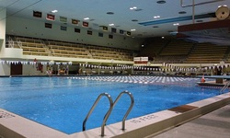
Blodgett Pool features an 8 lane, 50 meter competition course with Kiefer
Advantage II lane lines, a fully automatic Daktronics Timing System with alphanumeric scoreboard, and touch
pads at both ends of the course. There is a diving well area that will be available for warm-up and warm-down
activities. The facility has seating for 1200 spectators. The pool is located near the Harvard Football Stadium,
at 65 North Harvard Street, Boston MA 02163.

COURSE: Long course meters (50 meters).
PARKING: Primary parking will be located at the Harvard Business School parking lot the parking charge will
be between $5–$10. Parking may be available around the Harvard football stadium at a cost of $10.
DIRECTIONS:
From the West: Take the Massachusetts Turnpike east to Exit 18 (Allston/Cambridge). After paying toll, bear
left at fork towards Allston. Turn right at second set of lights onto North Harvard Street. Proceed approximately
one mile. The entrance to theHarvard Business School parking lot will be on your right, on Albert H. Gordon
Road, opposite the football stadium.
From the North: Take I-93 south to Storrow Drive exit. Take Storrow Drive west for approximately five miles.
Exit at Harvard Square/North Harvard Street. At the top of the exit, turn left onto North Harvard Street .
Approximately 1/4 mile on your left will be the entrance to the Harvard Business School parking lot, on Albert
H. Gordon Road, opposite the football stadium.
From the South: Take I-95 north to I-93 north. Follow I-93 to Exit 20 (Massachusetts Turnpike). Take Mass.
Pike west to Exit 20 (Allston/Cambridge). After paying toll, bear left at fork towards Allston. Turn right at
second set of lights onto North Harvard Street. Proceed approximately one mile. The entrance to
the Harvard Business School parking lot will be on your right, on Albert H. Gordon Road, opposite the football
stadium.

MIT - Zesiger Center, MIT, 120 Vasser Street, Cambridge, Ma. 02139
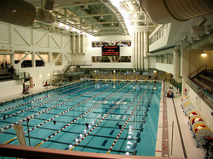
The MIT Competition Pool at the Zesiger Center is an 8-lane, 50 meter pool with seven-foot-wide lanes and
non-turbulent lane lines. Fully-automatic Colorado Time System touchpad’s and electronic display. Spectator
seating for 450. The depth of the water at the start end is 7 ft deep and is 13ft at the turn end.

COURSE: Short course yards (25 yards) and Long Course Meters (50 meters).
PARKING: Parking in Cambridge and Boston is generally not an enjoyable experience. Whenever possible, park your car at the hotel at which you are staying, and use public transportation to get to the MIT campus. If you must drive to the campus, there are both on- and off-street parking available, but most public parking is not
very close to the center of the MIT campus (unless you arrive early in the morning or late in the evening). There is metered parking on Massachusetts Avenue. There are a number of lots at which you may park for a fee. These include a lot at the corner of Massachusetts Avenue and Vassar Street, "Park and Lock" on Third Street,
"Kinney Systems" at 4 Cambridge Center (entrances on Ames Street and Broadway), and "Kinney Systems" at Ten Cambridge Center (entrances from Broadway and Binney Street).
DIRECTIONS:
From the North (I-95 or I-93) If you are heading south on I-93, follow I-93 into Boston then follow the I-93 instructions below. If you are heading south on I-95, take the I-93 South exit then follow the instructions from I-93. Alternatively, take the I-90 East exit from I-95 then follow the instructions from I-90.
From the South (I-95 or I-93) If you are heading north on I-93, follow I-93 (the Southeast Expressway) into Boston then follow the I-93 instructions below. If you are heading north on I-95, take the I-93 North exit then follow the instructions from I-93. Alternatively, take the I-90 East exit from I-95 then follow the instructions from I-90.
From the West (I-90) (Mass Turnpike) Follow I-90 east to the Cambridge/Brighton exit (exit 18). Following the signs to Cambridge, cross the River Street Bridge, and continue straight about 1 mile to Central Square. Turn right onto Massachusetts Avenue and follow Massachusetts Avenue for about a half mile. The main entrance to MIT will be on your left. If you cross the river again, you have gone too far.
From Route I-93 From I-93, take exit 26, and follow the signs to Back Bay along Storrow Drive West, approximately 1.5 miles, to the exit for Route 2A. The exit will be on the left, just before the Harvard Bridge (more appropriately called the Massachusetts Avenue Bridge). The Charles River will be on your right. As you cross the bridge, you will be looking at MIT - the Great Dome and academic facilities are on the right, the dormitories and athletic facilities are on the left.

Phillips Exeter Academy - Roger A. Nekton Championship Pool, Exeter, NH
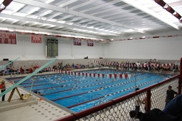
Phillips Exeter Roger A. Nekton Championship Pool is an 8-lane, 25-yard pool with
seven-foot wide lanes and non-turbulent lane lines. Fully-automatic Colorado Time Systems
electronic timing with touchpads at the finish end of the pool with eight-line electronic display.
There are no touch pads at the turn end of the pool. The finish end of the pool is 7 feet deep; the
turn end of the pool is 12 feet 6 inches deep. Spectator seating for 600.

COURSE: Short Course Yards (25 Yards)
Parking: Parking is available on public streets where parking is permitted and in the Academy Athletic Faculty parking lot behind the hockey rink and Love Gymnasium. Improperly parked cars will be ticketed and/or towed at the owner’s expense.
DIRECTIONS:
From North or South: Route I-95 to Exit 2. At tolls take Route 101 West to Portsmouth/Stratham exit 11 (Route 108). Take left at end of ramp, following Route 108 South to T intersection, turn right. At the bandstand in downtown Exeter, turn left (still 108). Take a left at the top of the hill onto Court St. (Route 108). Turn left just after the tennis courts on the left. Parking is on the right.
From East or West: Route 101 to the Portsmouth/Stratham exit 11
(Route 108). Follow directions from Route 108 South above.

Salem State College- O'Keefe Athletic Complex, 352 Lafayette Street, Salem MA 01930
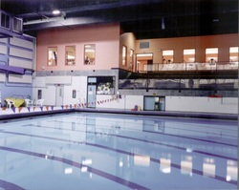
The Salem State University Competition Pool is an 8-lane, 25-yard pool with seven-foot-wide lanes and non-
turbulent lane lines. Fully automatic Colorado Time Systems with touch pads and full 8 lane electronic scoreboard
display. Balcony spectator seating for 250 people and deck seating for 350 coaches and officials. The pool is
located inside the Salem State College O’Keefe Athletic Complex, 352 Lafayette Street, Salem MA 01930.

COURSE: Short Course Yards (25 Yards)
Parking: Parking is free and available at the school parking lot.
DIRECTIONS:
From 128N take Exit 25A toward Salem (114E). Follow 114E through downtown Salem onto Route 1A (Canal Street). Stay on Canal Street 1 1/2 miles, Salem State O’Keefe Center will be on left. Walk up ramp to complex entrance.

Upper Valley Aquatic Center- 100 Arboretum Lane, White River Junction, Vermont
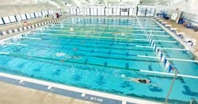
The competition pool has eleven 7 foot wide 25 yard long lanes, with non-turbulent lane lines, Colorado Timing System electronic touch pads and alphanumeric display scoreboard. The minimum depth of the pool is seven feet deep at the start end and nine feet deep at the turn end. There are no touch pads at the turn end of the pool.

COURSE: Short course yards (25 yards)
PARKING: Free but limited parking is available at the facility. Carpooling is appreciated.
DIRECTIONS:
The Upper Valley Aquatic Center (UVAC) is located at 100 Arboretum Lane in White River Junction,
Vermont 05001. (Arboretum Lane may not be on your GPS unit or web applications – it is across Route
5 from 1 Wright Reservoir Rd, White River Junction)
- At the junction of Interstates I-89 and I-91 in Vermont, go north on I-91 and immediately take Exit 11
for White River Junction.
- Turn left off the exit (before the stop light) on to Route 5 South.
- Follow Route 5 immediately under the interstate
- Travel ½ mile, go under the other interstate, and take the next left on to Arboretum Lane.
- UVAC is the only building on Arboretum Lane.

Raco - Raco Theodore Park on Head Street in Manchester NH
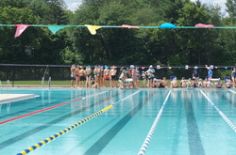
The Raco Theodore Swimming Pool is a 10-lane, 50 Meter x 25 yard pool with seven-foot-wide lanes with at least one lane for warm-ups. The start end of the pool is 7 feet deep; the turn end of the pool is 4 feet deep. Fully-automatic electronic timing with touch pads may be used for all events longer than 50 meters. Some or all of the 50 meter events may be timed with stop watches only. The pool is located at Raco Theodore Park on Head Street in Manchester NH.

COURSE: Short course yards (25 yards) and Long Course Meters (50 meters).
PARKING: Parking is available in a field near the pool area and in other designated areas. To access the field take a right on Dunham Street off Head Street. The lot is at the bottom of the hill. Illegally parked cars may be ticketed and or towed at the owners expense.
DIRECTIONS:
From the North, take 293 South to exit 5 for Granite St towards West Manchester. At Lights turn Right onto Granite St. At Second set of lights take a Left. You will be on S. Main St. Follow .3 Miles until you come to a set of lights at a Walgreens. Turn Right. You will be on Varney St. Take your first Right onto Head St, the swimming pool will be on the left.
From the South, take 293 North to exit 4. Take a right onto Second Street. Go to the 2nd set of lights and take a left onto West Hancock Street. At the end of street take a right onto Main Street. At lights take a left onto Varney Street. Take your first right onto Head Street, the park will be on the left.

Charles C. White Pool at Haverhill High School
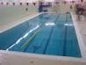
Pool General Information:
Facility Type: School/College/University
Facility Accessibility: Private
Pool Details:
Amenities: Lifeguard On Duty, Showers, Locker Rooms
Activities Offered: Lap Swimming, Water Excercise, Swim School, Open Swim (Recreational Swimming), Private Swim Lessons
Equipment: Kick Boards, Pace Clocks, Pulling Gear, Backstroke Flags, Lane Lines
Teams/Clubs: High School Swim Team, USA Swimming Team
Pool Specifications:
Pool Name: Charles C. White Pool at Haverhill High School
Indoor/Outdoor: Indoor Pool Length: 25 Yards Lanes: 6 Chlorine
Directions:
137 Monument Street , Haverhill , MA 01832

Peterborough, NH Adams Playground Pool
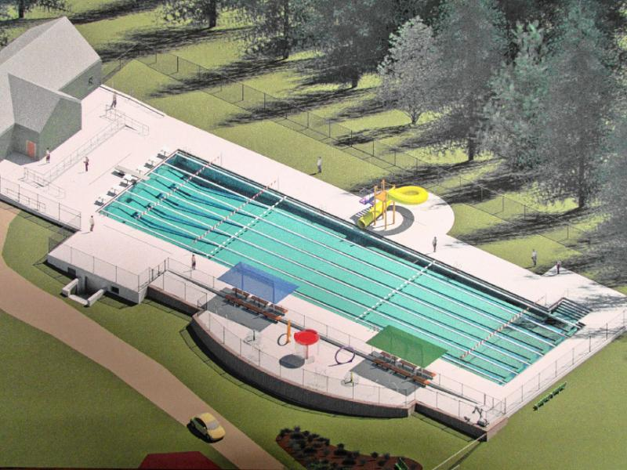
The pool at Peterborough’s Adams Playground is a six-lane, 50-yard outdoor pool surrounded by a grassy area for spectator seating.
Location: Adams Playground
64 Union St, Peterborough, NH 03458
(603) 924-8080 Peterborough, NH
Fenced playground area, tennis courts, skate park and baseball diamonds are also on the site too.

